**How to Technical Document**

**MongoDB**

MongoDB Install

* It is recommended but not required to install a local MongoDB Database prior to migrating to the cloud. To install the MongoDB Community Server, use the below link and download the current version of MongoDB Community Server.
  + [mongodb.com download](https://www.mongodb.com/try/download/community)
* MongoDB 4.4 and later versions also require, MongoDB database tools to be installed separately. The link below will guide below you to install MongoDB Database Tools.
  + MongoDB Database Tools Windows Install

**Fundamental Database Operations**

* After following instructions above to install MongoDB as a Windows Service, enter the Mongo shell from a terminal window. Screenshot below.

* To create a database, use the below command MongoDB has a **use DATABASE_NAME** command. The database name for our application is **devices**
  + Example: **use devices**

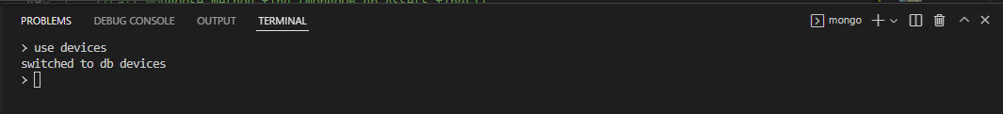

* To display all the existing database collections, type **show collections**. The screenshot below displays the current database collections; assets, devices, and users.

* You can exit the MongoDB by using CTRL + C.

MongoDB Atlas Install

* Sign up for a MongoDB Atlas account at MongoDB using the below link
  + [MongoDB Create Your Account](https://account.mongodb.com/account/register)
* Follow the tutorial in the link below to setup a Free Tier Cluster. The screenshot below displays a deployed database cluster.
  + [Deploy a Free Tier Cluster](https://docs.atlas.mongodb.com/tutorial/deploy-free-tier-cluster/)

* Use the Database Access tab (highlighted in screenshot below) to add a new user (highlighted in screenshot below.

* Use the Network Access tab (highlighted in screenshot below) to add a new IP address

* To connect to the Database to the application, in the cluster dashboard, click the CONNECT button and select “Connect your application” and copy the connection string (highlighted below). Ensure you are using the correct database name. Example screenshot currently using “myFirstDatabase”, while our application database will be named “devices”.

* In Visual Studio Code, add the connection string to the app.js file of the Content Manager 2.0 application as show below. Next, in the Terminal, start your Angular app using the **ng serve command** as as the server side using the **nodemon webserver.js** command.

* Confirm Atlas Database is functioning as expected, view the collections as you perform add, delete, and update functions within the application.Graphical user interface, text, application

  Description automatically generated

**Express**

Express Installation

* Prior to installing express, you will need to ensure NPM is installed. To verify installation and check the current version, type **npm --version** in the Command Prompt or a Terminal. If installed, you should see version number displayed. See screenshot below

* Within the web application folder, install Express using the command **npm install express**

**NodeJS**

NodeJS Installation

* Use the below link to download the latest version of node that is “Recommended for Most Users”
  + [nodejs.org download](https://nodejs.org/)
* Once the file is downloaded and installed, run **node -v**, followed by the **npm *-v*** in the Command Prompt or the Terminal to confirmed the version numbers installed. Next install nodemon using **npm install -g nodemon #** to access the nodemon tool to automatically restarting the node application when file changes in the directory are detected.

* Now that node and nodemon has been installed, you can now start the webserver using the webserver.js file within the application folder, using the **nodemon webserver.js** command. The screenshot below displays an example connection. Text

  Description automatically generated
* Quit the webserver connection using **CTRL + C.**

**Angular**

Angular Installation

* Prior to installing angular and from the command prompt, download and install git using the below link
  + <https://git-scm.com/downloads>.
* Install the Angular command line interface using the below command
  + **npm install -g @angular/cli@latest**
* Now that Angular is installed, change directories to the workspace directory containing the Content Manager 2.0 application and type **ng serve** to start.
* In your web browser, type the default home angular application url shown below to access the homepage of the application.
  + [**http://localhost:4200/home**](http://localhost:4200/home)

**Install Dependencies**

The below commands install additional dependencies used in the Content Manager 2.0 application

* Install latest angular material release and update package.json
  + **npm install angular-material –save**
* Install latest angular button release
  + **npm i @material/button**
* Install cors
  + **npm install cors**